Rethinking the Road Effect Zone

Michael J. Noonan $​^{1*}$, Arnaud L. J. Desbiez, Adam T. Ford $​^{1}$

1 – Department of Biology, The University of British Columbia, Okanagan Campus.

**\*Corresponding Author**: [michael.noonan@ubc.ca](mailto:michael.noonan@ubc.ca)

**Article type:** Note

|  |  |  |
| --- | --- | --- |
|  |  |  |
| Words in the abstract: 143 |  | Number of Figures: 3 |
|  |  |  |
| Words in main text: 2,339 (3,000 max) |  | Number of tables: 0 |
|  |  |  |
| Number of references: 31 |  | Supplementary material: 0 |

# Abstract

Roads are important for human socio-economic growth, but they carry substantial ecological impacts that can extend far beyond their physical footprint. This relationship has given rise to the so called `Road Effect Zone’. Although the foundational concept of the Road Effect Zone has proven useful in measuring patterns of biodiversity loss near roads, it focuses on changes in species presence/abundance, rather than the potential effects on ecological interactions. Here, we introduce a more nuanced road effect zone that brings together the probability of a wildlife-vehicle collision with the probability of an ecological interaction occurring across an animal’s home range. We demonstrate the utility of a probabilistic representation of the road effect zone for giant anteaters living near a highway in Brazil. We then conclude with a brief discussion of how this novel metric can be employed in practice to inform species conservation.

**Keywords:** Anthropocene, Anthropogenic impacts, GPS tracking, Home range, Movement ecology, Road ecology, Space use

# Introduction

The ca. 64,000,000 km of roads distributed across the globe are important for human socio-economic growth (Ibisch et al. 2016). Yet, while the area that roads occupy might be small, the ecological impacts they carry are substantial (Coffin 2007; Fahrig and Rytwinski 2009; Ascensão and Desbiez 2022), and can extend far beyond their physical footprint (Forman and Alexander 1998; Forman et al. 2003). From an ecological perspective, roads and roadside ecotones are considered high disturbance systems with non-natural chemical, physical, hydrological, and auditory properties (Reijnen, Foppen, and Meeuwsen 1996; Forman and Alexander 1998; Brady and Richardson 2017). Roads have been shown to alter population densities (Reijnen, Foppen, and Meeuwsen 1996; Fahrig and Rytwinski 2009; Andrasi et al. 2021), community composition (Truscott et al. 2005), evolutionary trajectories (Brown and Brown 2013; Brady and Richardson 2017), and are a serious source of non-natural mortality for many species (Desbiez, Bertassoni, and Traylor-Holzer 2020; Silva, Crane, and Savini 2020; Carter et al. 2020; Ascensão and Desbiez 2022). Fully understanding the ecological footprint of roads is thus of the utmost importance if we are to design well-informed ecological mitigation strategies.

Roads can cause a broad range of ecological impacts, but their effects are usually considered strongest with increasing proximity to the road surface. The strength or impact of these road effects decay at varying rates with increasing distance from the road. This relationship between the strength of effect and proximity to the road forms the basis for the concept of the `Road Effect Zone’ (Forman and Alexander 1998; Forman 2000), hereafter referred to as the REZ (Fig. 1). Ecologists and conservation practitioners regularly quantify the REZ for different species (e.g., Semlitsch et al. 2007; Eigenbrod, Hecnar, and Fahrig 2009; Andrasi et al. 2021), and these distances are often used to make conservation recommendations (e.g., Forman and Deblinger 2000; Peaden et al. 2015; Ford et al. 2020).

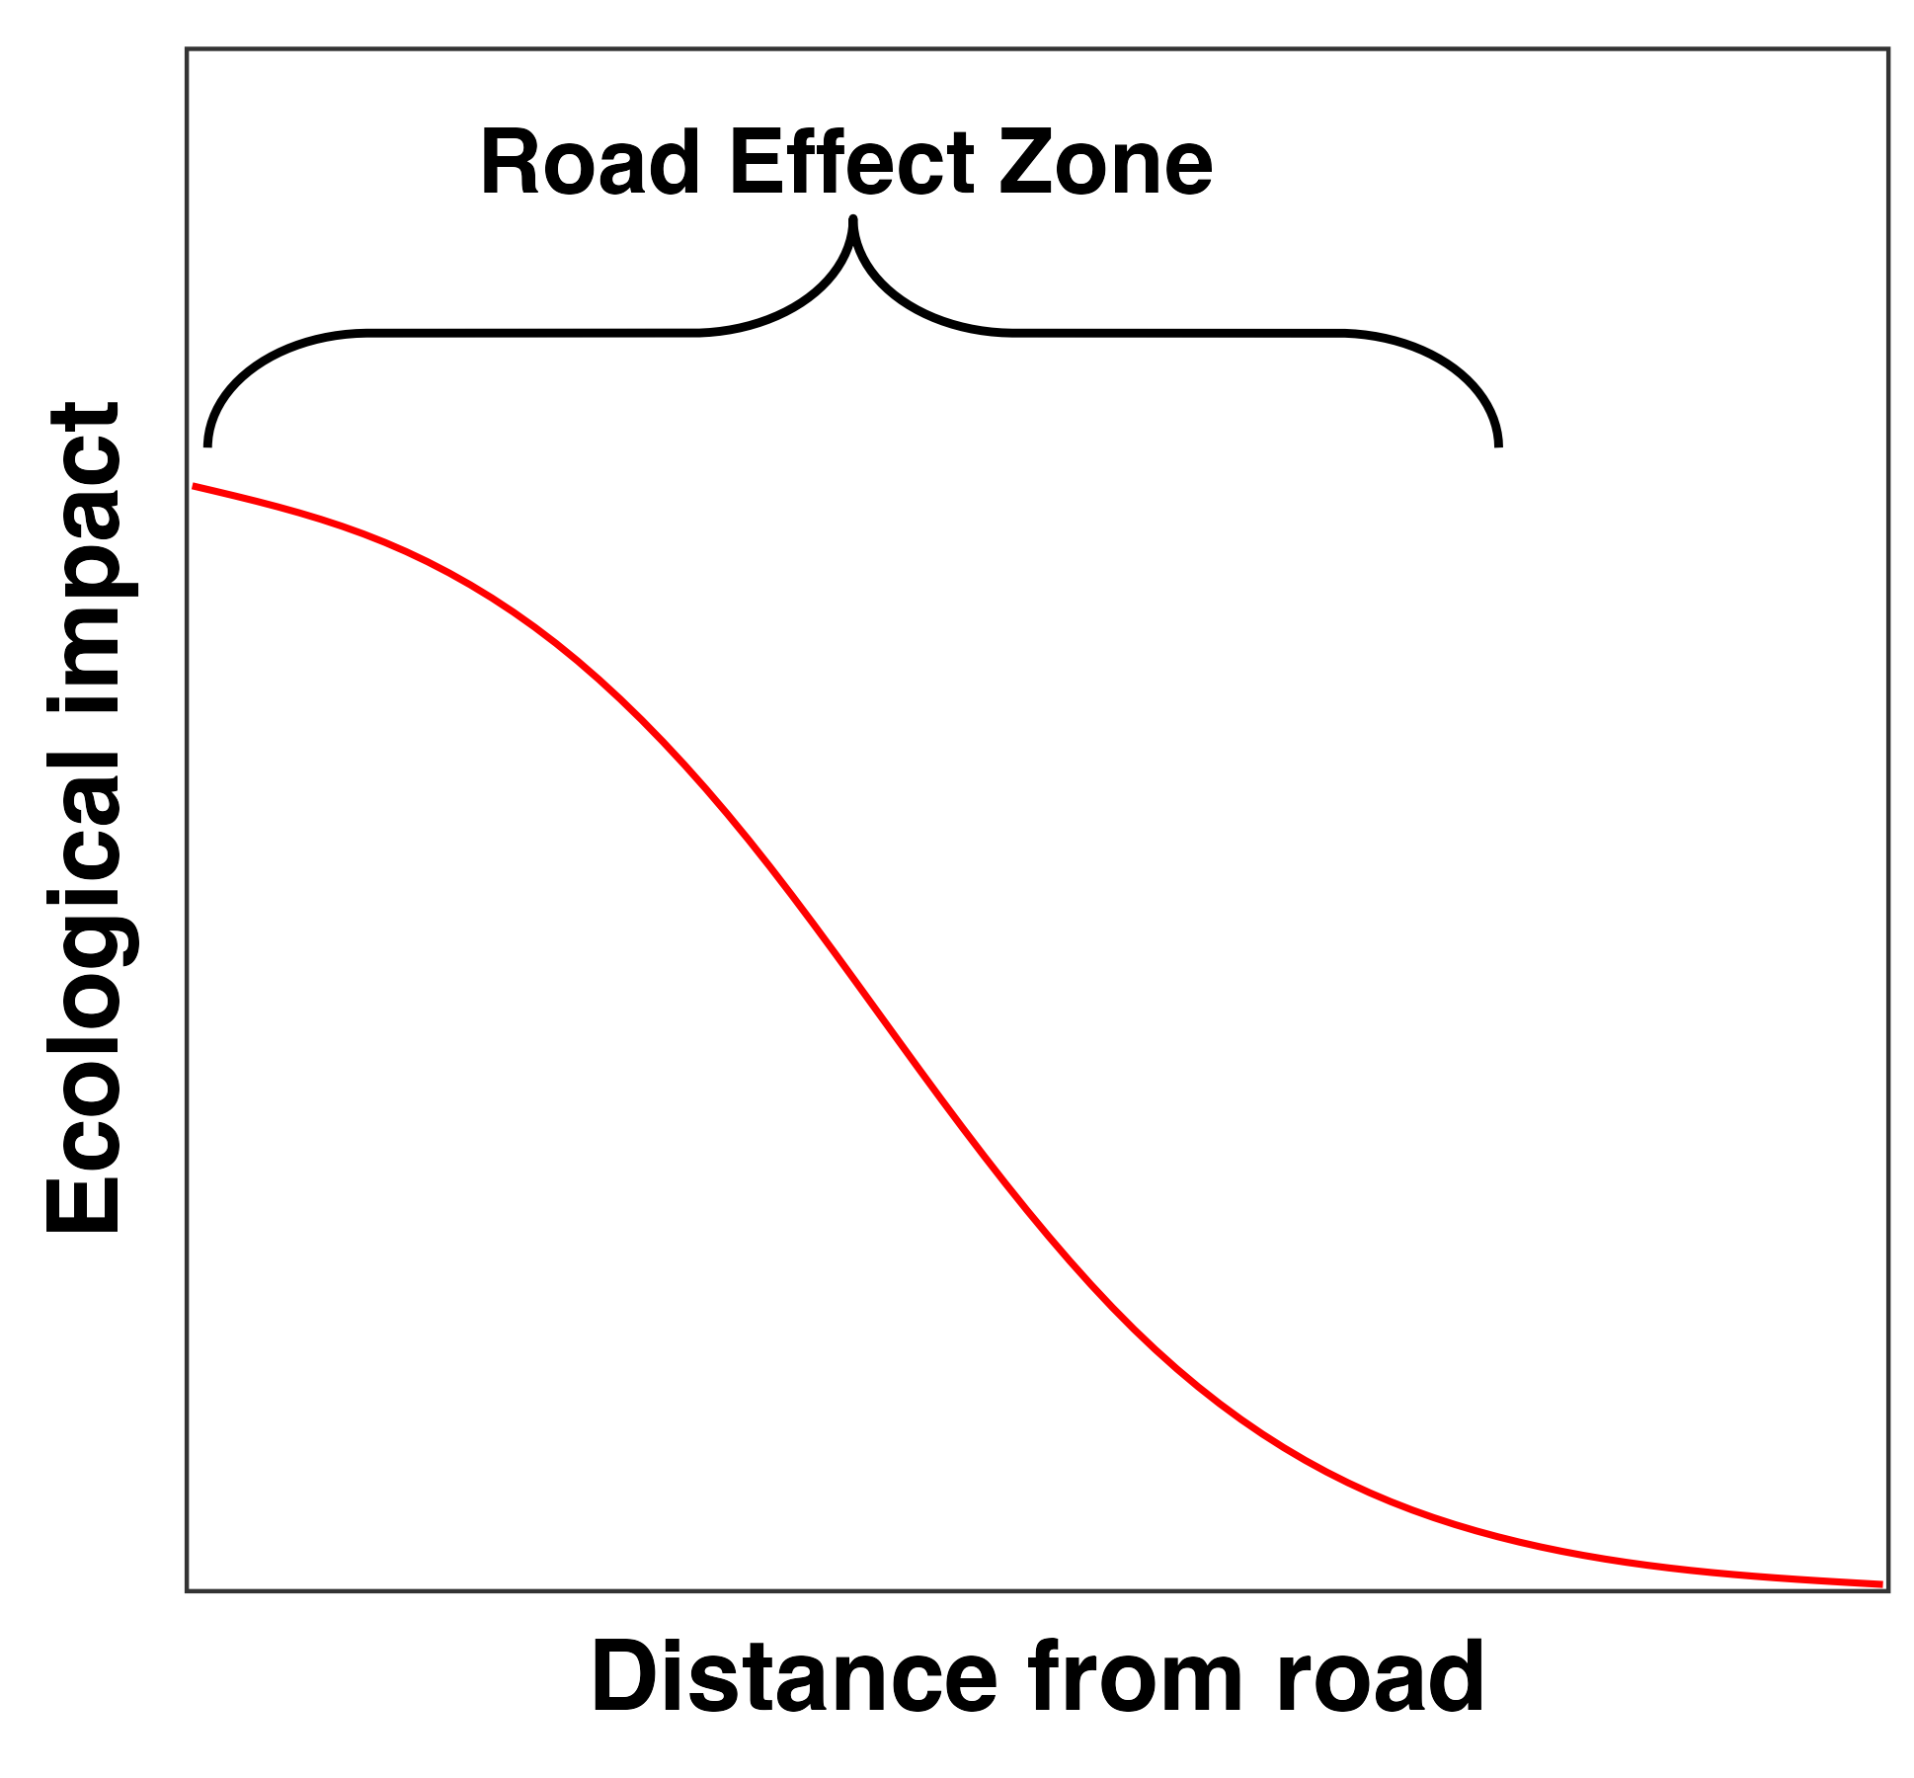

Theoretical depiction of the road effect zone as originally defined by Forman and Alexander (1998).

Although the REZ has proven useful in measuring patterns of biodiversity loss, it’s correlative basis combines several mechanisms that shape where and why roads affect nature. The REZ concept is also a static measure that does account for the dynamic effects animal movement and species interactions. This is a noteworthy limitation. Consider for instance, migratory ungulates that move over vast distance between seasonal home ranges (M. Kauffman et al. 2020; M. J. Kauffman et al. 2021). The effects of road mortality on these highly vagile animals might decrease nutrient transfer (Subalusky et al. 2017), prey densities (Walton et al. 2017), and/or grazing pressure (Augustine and McNaughton 1998) hundreds or even thousands of kilometers away from the road, yet these effects would not be captured within the current REZ framework. Similarly, for territorial species, the death of a roadside animal can have a cascading effect on the species’ socio-spatial arrangement over vastly larger distances than the conventional REZ might suggest as individuals disperse and restructure themselves around newly unoccupied territories (Mumme et al. 2000). The reduction in density of frugivorous and/or seed-caching animals around roads can also have cascading effects on seed dispersal over larger areas than described by the REZ (Tucker et al. 2021). Here, we introduce a more nuanced probabilistic road effect (PRE) that describes the broader ecological impacts that the mortality of an animal might have on the landscape.

# The Road Effect as a Joint Probability

As noted above, our focus is on the ecological impact of a wildlife mortality caused by a collision with a vehicle. Our framework begins from the concept of animal space use and movement ecology. An individual’s home range describes the space it uses to undergo `*its normal activities of food gathering, mating, and caring for young*’ (Burt 1943). Ecologists have long recognised the utility of the home-range concept in describing patterns of space use (e.g., Kie et al. 2010), and routinely estimate home ranges from animal tracking data (see Michael J. Noonan et al. 2019). Statistically, home-range estimation results in a probability distribution function ($PDF_{HR}$) satisfying

The $PDF_{HR}$ provides information on the locations where an animal is likely to be found. Importantly for the context of understanding the effects of roads on ecological processes, $PDF_{HR}$ also represents the sample space over which an individual’s ecological interactions (e.g., foraging, mating, defecating, engaging in territorial defence, etc.) are expected to occur. This PDF can thus be considered to be proportional to an animal’s impact on or from the ecosystem, with core (i.e., high probability) areas of the PDF being more heavily impacted by or from an animal than tail (i.e., low probability) areas. Under the assumption that the probability of an animal being roadkilled $P\{Roadkilled\}$ is proportional to the amount of time it spends on the road, we can quantify $P\{Roadkilled\}$ by integrating $PDF_{HR}$ over the area the falls on road surfaces

where $r$ and $r^{i}$ represent the road margins. Similarly, the probability of an animal engaging in normal ecological interactions, $P\{Ecological Interactions\}$, is proportional to the amount of time it spends in locations other than on the road

The ecological impact of wildlife vehicle collision is equivalent to the outcome of an animal not being able to engage in normal behaviour across its home range. This impact can thus be quantified via the joint probability of (1) an animal encountering a vehicle on a road and it being killed on the road, $P\{Roadkilled\}$, and (2) the probability of an animal engaging in ecologically relevant behaviour, $P\{Ecological Interactions\}$, or $P\{Roadkilled,Ecological Interactions\}$. Assuming independence, the PRE is given by the joint probability of these two events

If an animal occupies a home range that is far away from a road $P\{Roadkilled\}$ will be $≈$ 0, resulting no road effect. Similarly, if an animal spends all of its time on roads, $P\{Roadkilled\}$ may be high, but $P\{Ecological Interactions\}$ in areas away from the road will be $≈$ 0, also resulting in no road effect. For animals where $P\{Roadkilled\}≠0$ and $P\{Ecological Interactions\}≠0$, however, the road effect will be some non-zero probability with a strength that is a function of how much time an animal spends on roads relative to the rest of its home range. Thus, the strongest PRE must occur for animals that strongly interact with both roads and areas away from roads. Similarly, organisms with large home ranges have more diffuse ecological interactions, whereas animals with smaller home ranges have denser interactions over an equivalent time period. While this general concept is useful, we can also integrate over areas of interest to calculate the local PRE. For instance, the PRE within some distance threshold of a road can be quantified as

where $z$ and $z^{i}$ represent distance thresholds from the road edge. For example, setting $z$ to 0m and $z^{i}$ to 1m would provide the probability of a road effect within 1m of the road edge. Defining the road effect zone in this way allows it to flexibly take individual-specific forms based on each animal’s movement ecology (Fig. 2). Notably, although our focus here is on the ecological impacts of roadkilled animals, the concepts presented herein can be readily extended to other spatially explicit ecological processes, such as the area a root or mycelial network diffuses through (Bielčik et al. 2019).

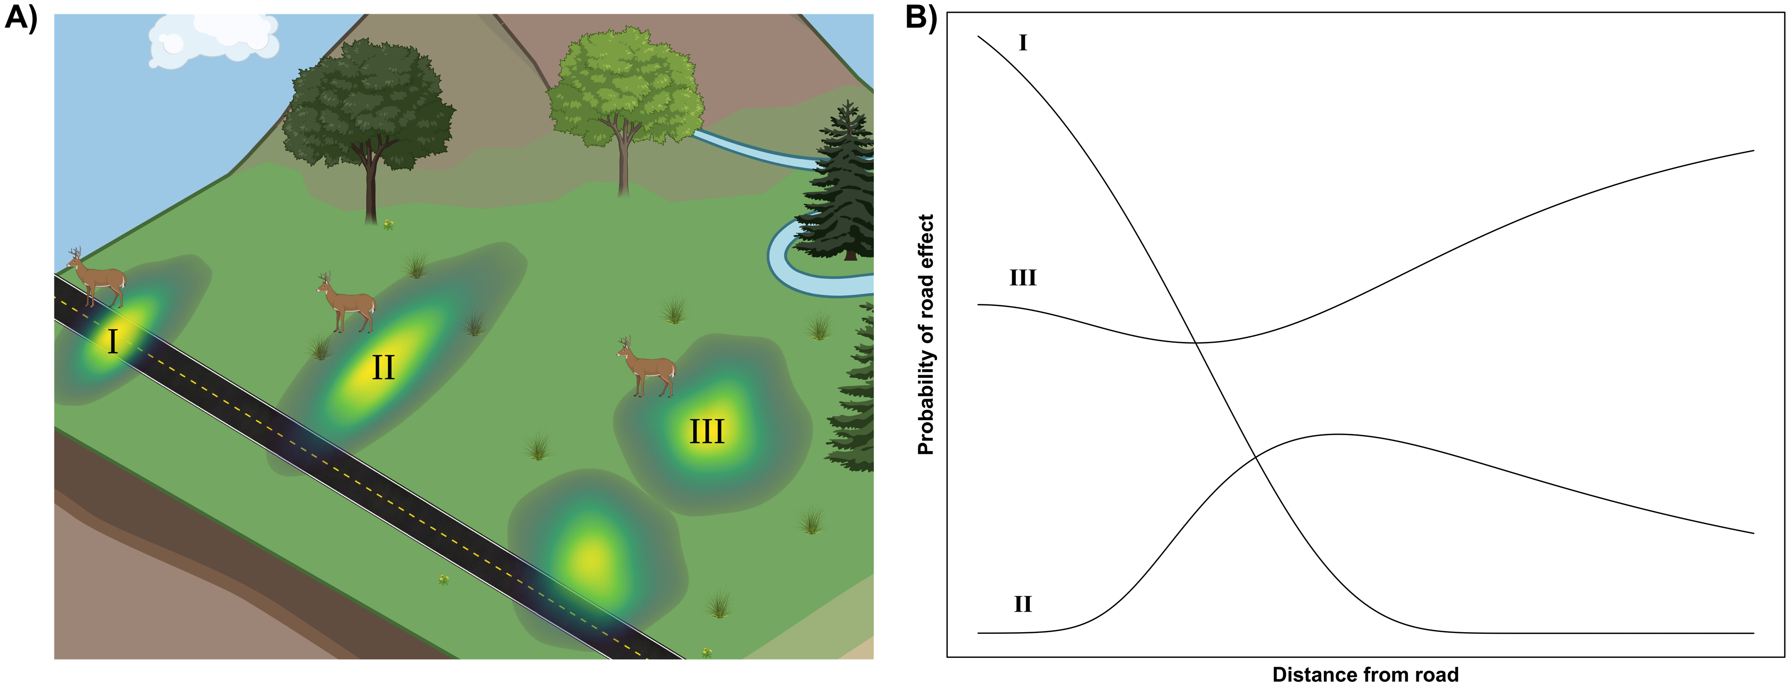

Theoretical depiction of the probabilitic road effect (PRE). Pnel A shows three animal home ranges that vary in extent and overlap with a road. Animal I has a small home range with high road overlap, Animal II has a small home range with low road overlap, and Animal III has a large home range with intermediate overlap. Note how the three different patterns of space use shown in A result in different PREs in B. As more home range area overlaps with roads, the probability of a road mortality increases, thereby increasing the probability of a road effect occurring. Similarly, as an animal’s home range increases, its ecological effects become more diffuse and the effects of a road mortality may be felt over a larger area. Panel A was created with BioRender.

# The Probabilistic Road Effect for Giant Anteaters

Here, we demonstrate the utility of a probabilistic representation of the road effect on a pair of giant anteaters (*Myrmecophaga tridactyla*) from the Brazilian Cerrado. Giant anteaters are the largest extant anteater, reaching over 2 m and weighing up to 50kg (McNab 1984) and are distributed throughout Central and South America (Gardner 2008). Giant anteater populations have suffered severe reductions and wildlife-vehicle-collisions are a major threat to their survival (Ascensão et al. 2021; Michael J. Noonan et al. 2022). Wild giant anteaters were captured between 2017 and 2018, in the vicinity of the three paved highways in the state of Mato Grosso do Sul, in the Cerrado biome, and equipped with tracking collars that obtained GPS fixes at 20-min intervals (for full details see Michael J. Noonan et al. 2022). A preliminary analysis on these data suggested that these individuals occupied fixed home ranges that regularly overlap paved highways. Following the workflow described above, we estimated the PRE for these two individuals in (ver. 4.2.1, R Core Team 2016). Home range areas were estimated using Autocorrelated Kernel Density Estimation (AKDE, Fleming et al. 2015) via the package (ver. 1.1.0, Calabrese, Fleming, and Gurarie 2016). The scripts required to reproduce these analyses and estimate the PRE from animal tracking data are openly available at <https://github.com/NoonanM/Road_Effect_Zone>.

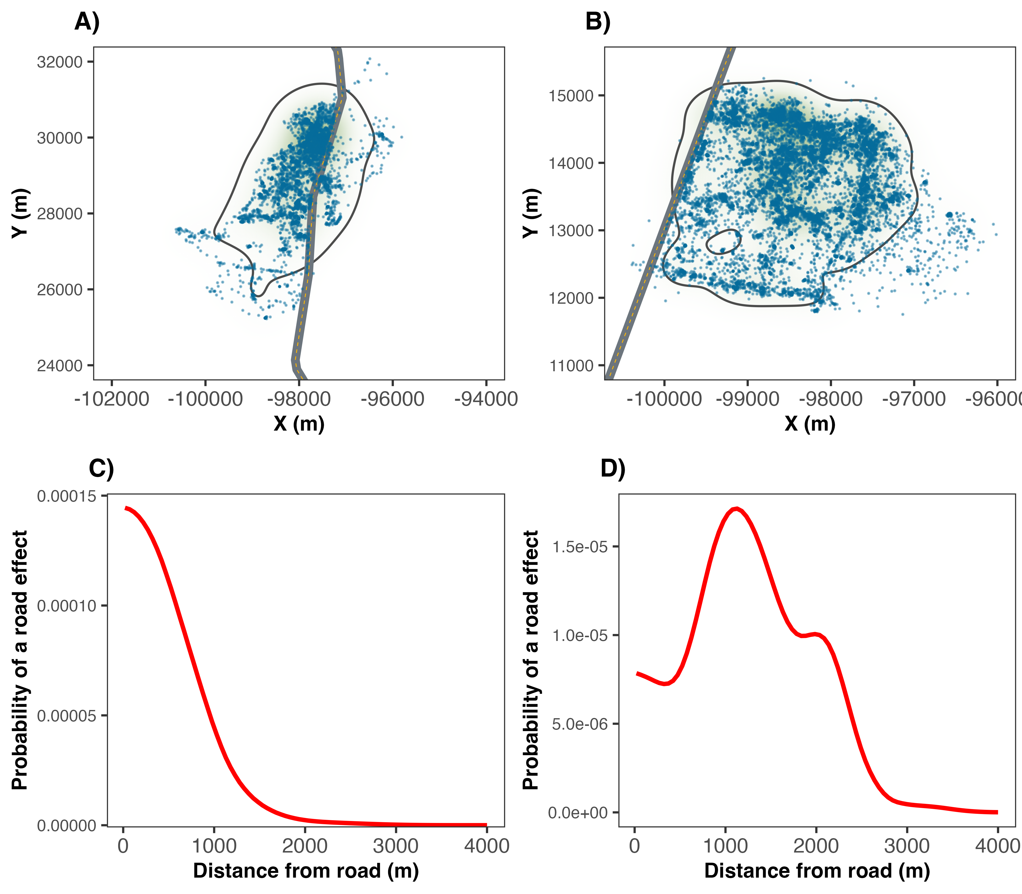

The relationship between space use and the road effect zone for two giant anteaters in the Brazilian Cerrado. Note how in panel A), the animal lives right along the roadside, so the ecological effects of a road mortality are greatest near the road, as shown in panel C). In Panel B), the animal’s home range was further from the road and while the overal road effect was weaker, it peaked between 1-2km from the road.

The two animals we estimated PREs for exhibited two different patterns in space use. One animal occupied a home range that was centered on the road (Fig. 1A), whereas the other occupied the roadside and surrounding area, but spent little time on the road itself (Fig. 1B). As would be expected for the animal that lived right along the roadside, the ecological effects of a road mortality were greatest near the road (Fig. 1C). For the second animal, their home range was further from the road, resulting in a weaker overall road effect, but one that peaked in probability between 1-2km from the road (Fig. 1D). In other words, although $P\{Roadkilled\}$ was greater for the first giant anteater, the road has the probability to impact the ecosystem more than 2km away from the road through the loss of the second giant anteater.

# Discussion

The idea that ecological conditions will be more pristine the further one moves from away from a road has been a focal point of road ecology research since Forman and Alexander (1998) first introduced the concept of the Road Effect Zone more than two decades ago (Reijnen, Foppen, and Meeuwsen 1996; Forman and Alexander 1998; Forman and Deblinger 2000; Semlitsch et al. 2007; Eigenbrod, Hecnar, and Fahrig 2009; Peaden et al. 2015; Brady and Richardson 2017; Andrasi et al. 2021). This conventional REZ focuses on quantifying the area over which roads alter measurable ecological impacts, typically community composition or population densities (Reijnen, Foppen, and Meeuwsen 1996; Truscott et al. 2005; Fahrig and Rytwinski 2009; Andrasi et al. 2021). While this concept has proven informative for understanding the ecological footprint of roads, the static nature of the REZ means that impacts related to animal movement and species interactions are not captured. For instance, consider a situation where there is a measurable reduction in the population density of a species near a road. This effect may be due to increased road-induced mortality, but it may also be due to road-avoidance and altered movement. Each of these mechanisms may reduce roadside population densities, but each would have different ecological impacts and require different mitigation strategies. Here we demonstrate how probability theory can provide a powerful tool for re-thinking the road effect zone, and an individual-based framework for scaling up to population-, or community-level effects.

Of note is the fact that our PRE framework as defined here relies on the assumption that an animal’s probability of being road-killed is directly proportional to the time it spends on a road. This is clearly an overly simplistic assumption as factors such as traffic volume and learning will impact mortality rates (Mumme et al. 2000; Langevelde and Jaarsma 2005; Ford and Fahrig 2007; Michael J. Noonan et al. 2022; Ascensão and Desbiez 2022). Nonetheless, because our framework is based on quantifying the joint probability of independent events, incorporating additional information affecting $P\{Roadkilled\}$ is straightforward. Indeed, this flexibility is one of the strengths of this framework. For instance, if signage (e.g., altered speed limits, wildlife corridor notices, etc.) is being considered as a mortality reduction strategy, the effect should be a measureable reduction in $P\{Roadkilled\}$, and, consequently, $P\{Road Effect\}$. Similarly, if a practitioner is tasked with making recommendations on the placement of a road-crossing structure, the conventional REZ would suggest that the effects of reduced road mortality will be felt according to some exponential decay function as shown in figure 1. In reality, however, the capacity for animals to move freely across a roadway with $P\{Roadkilled\}=0$ (i.e., the benefit provided by the crossing structure) can have ecosystem-wide benefits over vastly larger distances than the conventional REZ might suggest, depending on the vagility and behaviour of the animals the crossing-structure would benefit. The PRE thus provides ecologists and conservation practitioners with a dynamic metric for quantifying the ecosystem-wide impacts of roads, and/or the benefits of management strategies.

In this study, we have developed a framework for estimating road effect zones from animal movement data. Using movement data from giant anteaters occupying roadside habitats in Brazil, we have demonstrated how this framework can be used in practice to understand the ecological impacts of a road, and help inform species management. Notably, this framework builds straightforwardly off of home-range estimation and requires no specialized data collection protocols, allowing researchers to easily quantify the potential ecological impacts of roads for a variety of taxa.

# Acknowledgments

This work was supported by an NSERC Discovery Grant RGPIN-2021-02758 to MJN, as well as the Canadian Foundation for Innovation. We would like to thank the donors to the Anteaters and Highways Project especially the Foundation Segre as well as North American and European Zoos listed at <http://www.giantanteater.org/>. We would also like to thank the owners of all the ranches that allowed us to monitor animals on their property, in particular Nhuveira, Quatro Irmãos and Santa Lourdes ranches and also thank to M. Alves, D. Kluyber, C. Luba, A. Alves, as well as all of the volunteers who assisted in carrying out the fieldwork.

# References

Andrasi, Balint, Jochen AG Jaeger, Stefanie Heinicke, Kristian Metcalfe, and Kimberley J Hockings. 2021. “Quantifying the Road-Effect Zone for a Critically Endangered Primate.” *Conservation Letters* 14 (6): e12839.

Ascensão, Fernando, and Arnaud LJ Desbiez. 2022. “Assessing the Impact of Roadkill on the Persistence of Wildlife Populations: A Case Study on the Giant Anteater.” *bioRxiv*.

Ascensão, Fernando, Débora R Yogui, Mario H Alves, Amanda Carolina Alves, Fernanda Abra, and Arnaud LJ Desbiez. 2021. “Preventing Wildlife Roadkill Can Offset Mitigation Investments in Short-Medium Term.” *Biological Conservation* 253: 108902.

Augustine, David J, and Samuel J McNaughton. 1998. “Ungulate Effects on the Functional Species Composition of Plant Communities: Herbivore Selectivity and Plant Tolerance.” *The Journal of Wildlife Management*, 1165–83.

Bielčik, Miloš, Carlos A Aguilar-Trigueros, Milica Lakovic, Florian Jeltsch, and Matthias C Rillig. 2019. “The Role of Active Movement in Fungal Ecology and Community Assembly.” *Movement Ecology* 7 (1): 1–12.

Brady, Steven P, and Jonathan L Richardson. 2017. “Road Ecology: Shifting Gears Toward Evolutionary Perspectives.” *Frontiers in Ecology and the Environment* 15 (2): 91–98.

Brown, Charles R, and Mary Bomberger Brown. 2013. “Where Has All the Road Kill Gone?” *Current Biology* 23 (6): R233–34.

Burt, William Henry. 1943. “Territoriality and Home Range Concepts as Applied to Mammals.” *Journal of Mammalogy* 24 (3): 346–52.

Calabrese, Justin M, Chris H Fleming, and Eliezer Gurarie. 2016. “Ctmm: An R Package for Analyzing Animal Relocation Data as a Continuous-Time Stochastic Process.” *Methods in Ecology and Evolution* 7 (9): 1124–32.

Carter, Neil, Alexander Killion, Tara Easter, Jodi Brandt, and Adam Ford. 2020. “Road Development in Asia: Assessing the Range-Wide Risks to Tigers.” *Science Advances* 6 (18): eaaz9619.

Coffin, Alisa W. 2007. “From Roadkill to Road Ecology: A Review of the Ecological Effects of Roads.” *Journal of Transport Geography* 15 (5): 396–406.

Desbiez, Arnaud Leonard Jean, Alessandra Bertassoni, and Kathy Traylor-Holzer. 2020. “Population Viability Analysis as a Tool for Giant Anteater Conservation.” *Perspectives in Ecology and Conservation* 18 (2): 124–31.

Eigenbrod, Felix, Stephen J Hecnar, and Lenore Fahrig. 2009. “Quantifying the Road-Effect Zone: Threshold Effects of a Motorway on Anuran Populations in Ontario, Canada.” *Ecology and Society* 14 (1).

Fahrig, Lenore, and Trina Rytwinski. 2009. “Effects of Roads on Animal Abundance: An Empirical Review and Synthesis.” *Ecology and Society* 14 (1).

Fleming, C H, W F Fagan, T Mueller, K A Olson, P Leimgruber, and J M Calabrese. 2015. “Rigorous home range estimation with movement data: a new autocorrelated kernel density estimator.” *Ecology* 96 (5): 1182–88.

Ford, Adam T, and Lenore Fahrig. 2007. “Diet and Body Size of North American Mammal Road Mortalities.” *Transportation Research Part D: Transport and Environment* 12 (7): 498–505.

Ford, Adam T, Emily J Sunter, Catherine Fauvelle, Jacob L Bradshaw, Brett Ford, Jenna Hutchen, Nicholas Phillipow, and Kristine J Teichman. 2020. “Effective Corridor Width: Linking the Spatial Ecology of Wildlife with Land Use Policy.” *European Journal of Wildlife Research* 66 (4): 1–10.

Forman, Richard TT. 2000. “Estimate of the Area Affected Ecologically by the Road System in the United States.” *Conservation Biology* 14 (1): 31–35.

Forman, Richard TT, and Lauren E Alexander. 1998. “Roads and Their Major Ecological Effects.” *Annual Review of Ecology and Systematics* 29 (1): 207–31.

Forman, Richard TT, and Robert D Deblinger. 2000. “The Ecological Road-Effect Zone of a Massachusetts (USA) Suburban Highway.” *Conservation Biology* 14 (1): 36–46.

Forman, Richard TT, Daniel Sperling, John A Bissonette, Anthony P Clevenger, Carol D Cutshall, Virginia H Dale, Lenore Fahrig, et al. 2003. *Road Ecology: Science and Solutions*. Island press.

Gardner, Alfred L. 2008. *Mammals of South America, Volume 1: Marsupials, Xenarthrans, Shrews, and Bats*. Vol. 2. University of Chicago Press.

Ibisch, Pierre L, Monika T Hoffmann, Stefan Kreft, Guy Pe’er, Vassiliki Kati, Lisa Biber-Freudenberger, Dominick A DellaSala, Mariana M Vale, Peter R Hobson, and Nuria Selva. 2016. “A Global Map of Roadless Areas and Their Conservation Status.” *Science* 354 (6318): 1423–27.

Kauffman, Matthew J, Francesca Cagnacci, Simon Chamaillé-Jammes, Mark Hebblewhite, J Grant C Hopcraft, Jerod A Merkle, Thomas Mueller, et al. 2021. “Mapping Out a Future for Ungulate Migrations.” *Science* 372 (6542): 566–69.

Kauffman, Matthew, Holly Copeland, Jodi Berg, Scott Bergen, Eric Cole, Matthew Cuzzocreo, Sarah Dewey, et al. 2020. “Ungulate Migrations of the Western United States, Volume 1.” US Geological Survey.

Kie, John G, Jason Matthiopoulos, John Fieberg, Roger A Powell, Francesca Cagnacci, Michael S Mitchell, Jean-Michel Gaillard, and Paul R Moorcroft. 2010. “The home-range concept: are traditional estimators still relevant with modern telemetry technology?” *Philosophical Transactions of the Royal Society of London. Series B: Biological Sciences* 365 (1550): 2221–31.

Langevelde, Frank van, and Catharinus F Jaarsma. 2005. “Using Traffic Flow Theory to Model Traffic Mortality in Mammals.” *Landscape Ecology* 19 (8): 895–907.

McNab, Brian K. 1984. “Physiological Convergence Amongst Ant-Eating and Termite-Eating Mammals.” *Journal of Zoology* 203 (4): 485–510.

Mumme, Ronald L, Stephan J Schoech, Glen E Woolfenden, and John W Fitzpatrick. 2000. “Life and Death in the Fast Lane: Demographic Consequences of Road Mortality in the Florida Scrub-Jay.” *Conservation Biology* 14 (2): 501–12.

Noonan, Michael J, Fernando Ascensão, Débora R Yogui, and Arnaud LJ Desbiez. 2022. “Roads as Ecological Traps for Giant Anteaters.” *Animal Conservation* 25 (2): 182–94.

Noonan, Michael J., Marlee A. Tucker, Christen H. Fleming, Tom Akre, Susan C. Alberts, Abdullahi H. Ali, Jeanne Altmann, et al. 2019. “A Comprehensive Analysis of Autocorrelation and Bias in Home Range Estimation.” *Ecological Monographs* 0 (0): e01344. <https://doi.org/10.1002/ecm.1344>.

Peaden, J Mark, Tracey D Tuberville, Kurt A Buhlmann, Melia G Nafus, and Brian D Todd. 2015. “Delimiting Road-Effect Zones for Threatened Species: Implications for Mitigation Fencing.” *Wildlife Research* 42 (8): 650–59.

R Core Team. 2016. *R: A Language and Environment for Statistical Computing*.

Reijnen, Rien, Ruud Foppen, and Henk Meeuwsen. 1996. “The Effects of Traffic on the Density of Breeding Birds in Dutch Agricultural Grasslands.” *Biological Conservation* 75 (3): 255–60.

Semlitsch, Raymond D, Travis J Ryan, Kevin Hamed, Matt Chatfield, Bethany Drehman, Nicole Pekarek, Mike Spath, and Angie Watland. 2007. “Salamander Abundance Along Road Edges and Within Abandoned Logging Roads in Appalachian Forests.” *Conservation Biology* 21 (1): 159–67.

Silva, I, M Crane, and T Savini. 2020. “High Roadkill Rates in the Dong Phayayen-Khao Yai World Heritage Site: Conservation Implications of a Rising Threat to Wildlife.” *Animal Conservation* 23 (4): 466–78.

Subalusky, Amanda L, Christopher L Dutton, Emma J Rosi, and David M Post. 2017. “Annual Mass Drownings of the Serengeti Wildebeest Migration Influence Nutrient Cycling and Storage in the Mara River.” *Proceedings of the National Academy of Sciences* 114 (29): 7647–52.

Truscott, Anne-Marie, SCF Palmer, GM McGowan, JN Cape, and S Smart. 2005. “Vegetation Composition of Roadside Verges in Scotland: The Effects of Nitrogen Deposition, Disturbance and Management.” *Environmental Pollution* 136 (1): 109–18.

Tucker, Marlee A, Michela Busana, Mark AJ Huijbregts, and Adam T Ford. 2021. “Human-Induced Reduction in Mammalian Movements Impacts Seed Dispersal in the Tropics.” *Ecography* 44 (6): 897–906.

Walton, Zea, Jenny Mattisson, John DC Linnell, Audun Stien, and John Odden. 2017. “The Cost of Migratory Prey: Seasonal Changes in Semi-Domestic Reindeer Distribution Influences Breeding Success of Eurasian Lynx in Northern Norway.” *Oikos* 126 (5): 642–50.